MODULE 1
Feature | static | final | abstract
Meaning | Belongs to the class | Cannot be modified | Defines incomplete methods/classes
Usage | Variables, methods, blocks | Variables, methods, classes | Methods and classes
Inheritance | Not inherited (shared) | Cannot be overridden/inherited | Must be inherited and implemented
Object Requirement | No object required | Object required | Cannot instantiate abstract classes
Method Body | Must have a body | Must have a body | No body (for abstract methods)
Combination | Cannot be abstract | Cannot be abstract | Cannot be static or final
Example | static int x = 5; | final int y = 10; | abstract void display();

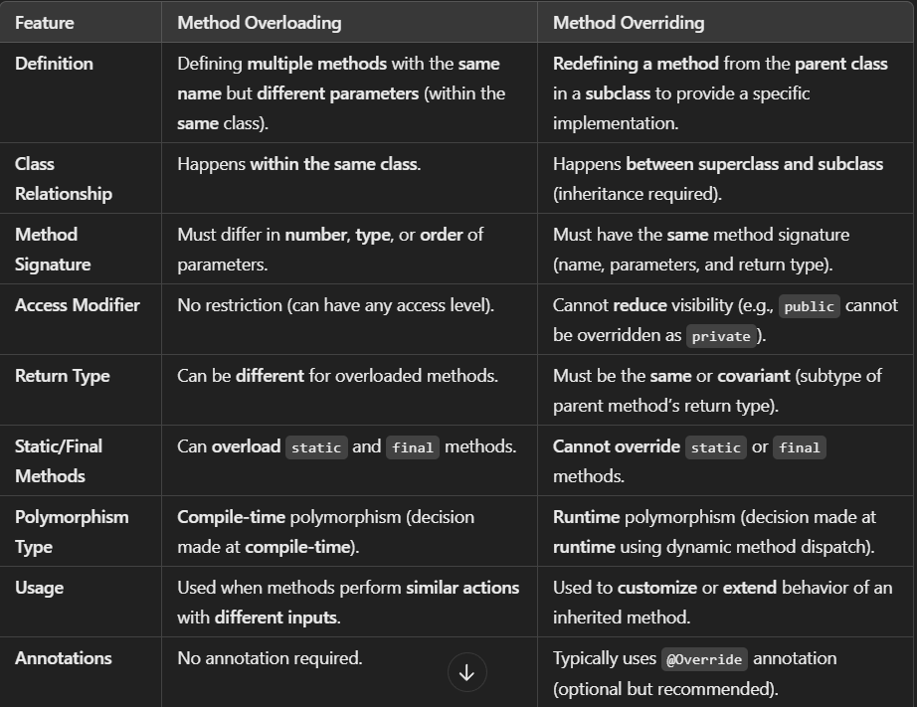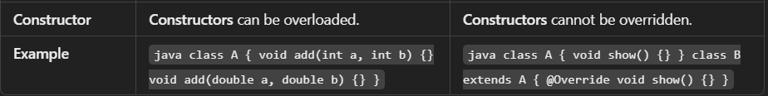

MODULE 2
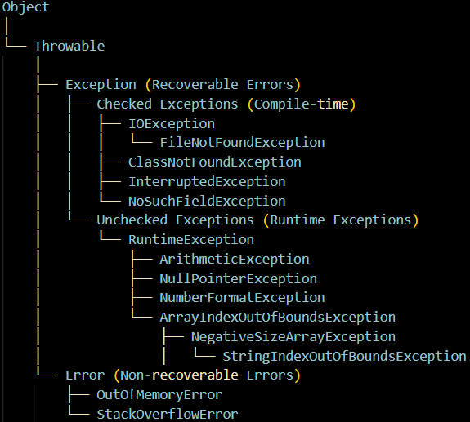
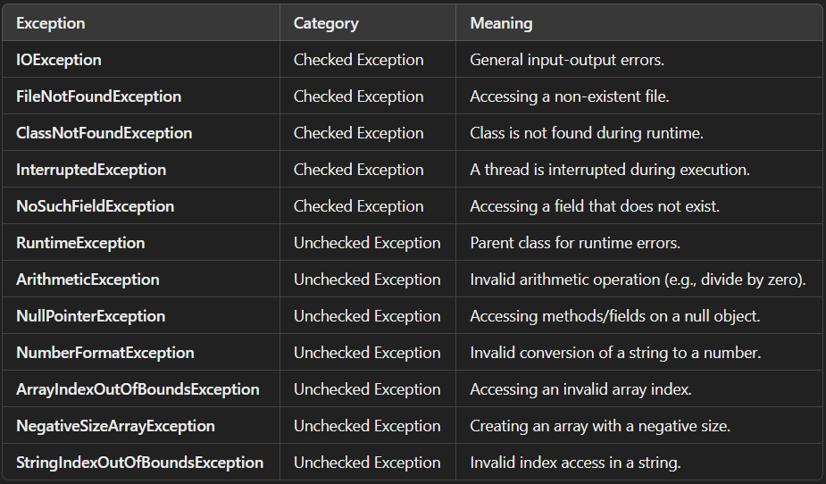

MODULE 3

MODULE 4
🔧 What is Maven?
- Maven is a build automation and project management tool developed by the Apache Software Foundation.
- Maven is used to build the code and manage dependencies (libraries like JAR files).
- In traditional Java projects, libraries like Spring or Hibernate must be downloaded and added manually. If the version changes, you have to redo everything.
- Maven automates this by allowing you to declare dependencies in a file called pom.xml, and it takes care of downloading and managing them.

🧱 Key Features of Maven
- Dependency Management: Just write the needed dependencies in pom.xml, and Maven will download and manage them.
- Build Automation: Maven handles tasks like compiling code, packaging, testing, etc.
- Project Management: It provides a standardized project structure and lifecycle.

⚙️ How Maven Works
- It uses conventions, meaning you don't need to specify everything—just the exceptions.
- The POM file (Project Object Model, pom.xml) describes:
  - The project itself
  - Its dependencies
  - Build order
  - Plugins and directories used
- Command to check if maven has been successfully installed and added to the path – mvn -version

🧩 Maven Architecture
A maven repository is a directory of packaged JAR file with pom.xml file. Maven searches for dependencies in the repositories. There are 3 types of maven repository:
- Maven local repository is located in your local system. It is created by the maven when you run any maven command.
- Maven central repository is located on the web. It has been created by the apache maven community itself.
- Maven remote repository is located on the web. Most of libraries can be missing from the central repository such as JBoss library etc, so we need to define remote repository in pom.xml file.

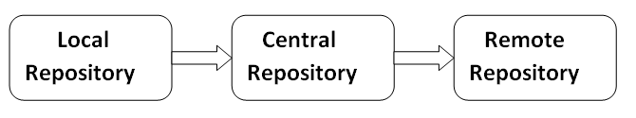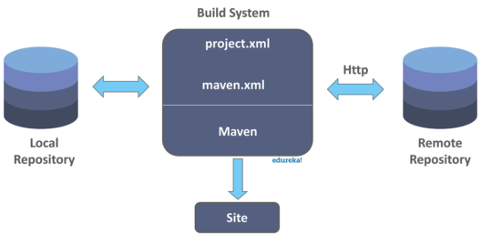
🔄 Maven Built-In Build Life Cycles
There are 3 main life cycles:
- Clean – Cleans up previous builds. It has 3 phases. 3 commands : mvn pre-clean, mvn clean, mvn post-clean
- Default – This phase handles the complete deployment of the project. It has 23 Phases. It is the main build process (compile, test, package, install).
- Site – Creates project documentation. It has 4 phases: pre-site, site, post-site, site-deploy.
The command used in maven to generate javadocs for a given project is 'mvn site'. Basically, when this command is invoked, maven calls 'Doxia' document generation and other report generating plugins.
Doxia is basically a framework used for content generation by maven. This generates contents both in static and dynamic ways.
- A lifecycle is organized into sequence of phases.
- Each phase is responsible for a specific task.
- Phases give order to a set of goals.
- These goals are chosen and bound by the packaging type of the project being acted on.
MAIN PHASES OF DEFAULT LIFE CYCLE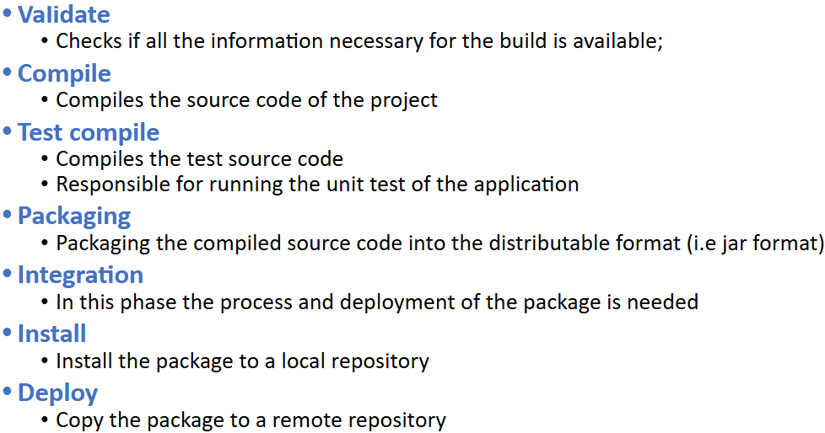

📍 Maven Coordinates (GAV)
These uniquely identify any dependency:
- project – It is the root element of pom.xml file.
- groupId – Who made the project (e.g., org.springframework)
- artifactId – The name of the library (e.g., spring-core)
- version – The version of the library (e.g., 4.3.8.RELEASE)
- modelVersion – Tells Maven how to read the pom.xml file
Additional Elements:
- packaging – defines packaging type such as jar, war etc.
- name – defines name of the maven project.
- url – defines url of the project.
- dependencies – defines dependencies for this project.
- dependency – defines a dependency. It is used inside dependencies.
- scope – defines scope for this maven project. It can be compile, provided, runtime, test and system.

📘 POM & Super POM
- POM (Project Object Model): It's the heart of any Maven project, stored in pom.xml.
- Super POM: A default POM provided by Maven that your project inherits from. It sets some default behaviors.

